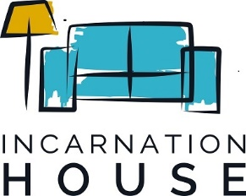

Drug and Alcohol Policy
Volunteers and/or guests are forbidden to enter our facility during program hours located at 4061 North Central Expressway, Dallas, TX while under the influence of narcotics and/or alcohol. Incarnation House staff holds the right to remove any volunteer or guest from our facility who is under the influence of above mentioned. Incarnation House staff holds the right to fire any volunteer who violates the above mentioned policy and said volunteer will be forbidden from volunteering with Incarnation House indefinitely.
Print Name: ____________________________________________________________
Signature: ______________________________________________________________
Date: __________________________________________________________________

Photo and Video Release
For valuable consideration received, I hereby authorize Incarnation House the absolute right to use, take, and publish photographs and videos of myself as they see fit. Said photographs and videos will be used for promotional, marketing, and various other uses by Incarnation House.

Print Name: ____________________________________________________________
Signature: _____________________________________________________________
Date: _________________________________________________________________

